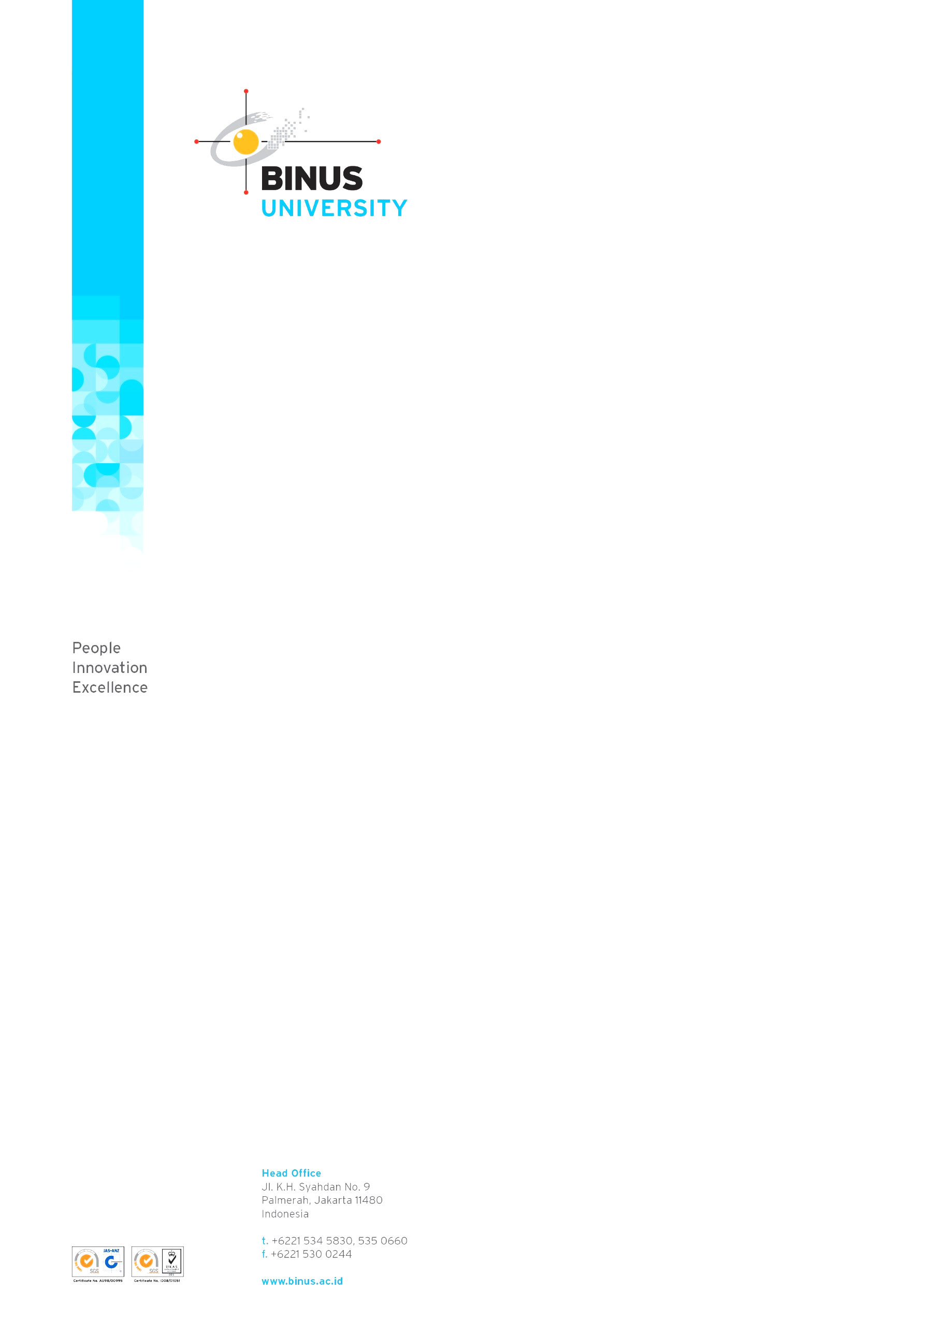

**PROJECT PROPOSAL**

**SOFTWARE ENGINEERING**

**COMP6100**



**LA08 (LEC)**

**Computer Science – Master Track**

|  |  |
| --- | --- |
| **Student ID** | **Student Name** |
| 2101626626 | Jonathan Sebastian Prayoga |
| 2101628594 | Nicholas Dominic |
| 2101628650 | Arvin Melvillo |
| 2101634911 | Daniel |
| 2101655020 | Andrian Syah Putra Leong |

**BINUS UNIVERSITY – School of Computer Science**

**MARCH 07th, 2019**

**JAKARTA**

1. **INTRODUCTION**

Great ideas have both figuratively and literally changed the world. From them, we have brought science, technology, and innovation to greater heights never sought of or even reached before. Countless improvements have been brought and applied to our lives and changed it for the better. Thanks to these great ideas and to the never-ending great minds that have unraveled them, we, as a species, are able continue our journey to strive for perfection, ingenuity, and brilliance. These important discoveries have an incredible impact for generations to come that was probably unthought of by the discoverer at the time. Some of these great discoveries have humble beginnings or was even discovered accidentally.

One such breakthrough is the X-Ray[1]. In 1895, Wilhelm Roentgen accidentally discovered X-Ray whilst performing an experiment using cathode rays. He realized that these rays were able to pass through solid objects and can generate image of the object that the rays have passed through. This technology was quickly adopted and had significant impact especially in the field of medical sciences. With this technology, doctors and medical practitioners will able to assess any internal damage suffered by the patient, and in the process, may safely diagnose and prescribe accurate medicines that will ultimately save the patient’s life. Without a doubt, this technology has an immeasurable impact to our lives.

Initially, these impactful ideas were thought of by a person or a group of persons. With enough effort, recognition, and support, these great ideas are then able to be applied and to serve humanity by a significant margin. Unfortunately, some great ideas did not have or gain the recognition and support that it deserves. Such cases are not unheard of especially in Indonesia. There were numerous great ideas that have been thought of and developed by this nation’s greatest minds, but were nevertheless ignored or thrown off by the general public. One such case is the electricity-powered sports car developed and created by Ricky Elson[2]. His electricity-powered sports car was not only a sight to behold, but also more importantly environment friendly by not having to reside and consume any fuel. Unfortunately, this car was not approved by the government because it did not pass the emission test. Instead of helping Elson develop the car further, the government decided to shelve off his brilliant product. It was quickly forgotten and quickly ignored by Elson’s own countrymen. Ironically, the government of Malaysia has shown great interest in Elson’s car and have decided to help develop it further.

With this Project Proposal, we are creating a platform that enables great ideas to be known and recognized, and ultimately help the idea to be developed further and able to be applied or created into a real-life product or service that will bring a significant impact to humanity, not only for a short while, but also for generations to come.

1. **IMPLEMENTATION AND DEVELOPMENT**
2. **PRODUCT DESCRIPTION**
3. **PRODUCT EXCELLENCE**

* The excellence of our product is to bring BINUSIAN Entrepreneur (active student of Bina Nusantara University who have business ideas that have been validated by BINUS Entrepreneurship Center) and BINUSIAN Investor (active student of Bina Nusantara University who contribute to developing business ideas by doing tasks given by BINUSIAN Entrepreneur) together.
* If other corporates provide a platform to donate money for start-ups or projects, ours offer job-desc-donation for register and approved BINUSIAN Entrepreneur start-ups. After completing their job-desc, BINUSIAN Investor will get an agreed reward.

1. **DEVELOPMENT PROCESS**

|  |  |
| --- | --- |
| *Date / Time* | *Activity Log* |
| March 05th, 2019  12 a. m. – 03 p. m. WIB | Our team pour out ideas into Project Proposal. |
| March 06th, 2019  10 a. m – 01 p. m. WIB | Build use case, activity, and class diagram. |
| March 19th, 2019  11 a. m. – 15 p. m. WIB | Revise Project Proposal and rebuild use case, activity, and class diagram. |

1. **CUSTOMER SERVICES**
2. **MAIN CUSTOMER TARGET**

Active BINUSIAN (Bina Nusantara University students) who want to contribute directly to develop other BINUSIAN start-ups.

1. **CUSTOMER SATISFACTION**

Customers (BINUSIAN Investors) will get a reward agreed upon from BINUSIAN Entrepreneur start-up that they helped through offered and approved job description.

1. **SERVICES QUALITY**

We are giving service for BINUSIAN Entrepreneurs to help them analyze their business opportunity and development. We also help to monitor the start-up track record so they can claim their customer reward immediately.

1. **MARKETING**
2. **MARKETING STRATEGY**

The type/platform in which we’ll try to reach out to our customers to introduce our products will be online marketing. The methods used include:

1. Social media sharing

We create our private social media accounts (such as LINE@, Instagram, Twitter, and YouTube) to share about our platform. We also broadcast our service through LINE / WhatsApp groups to engage BINUSIAN to “invest” in our client’s start-ups (BINUSIAN Entrepreneur).

1. Advertise on BINUS websites

We hopefully do a partnership with BINUS Entrepreneurship Center so we can advertise our platform on official BINUS websites.

1. **MARKETING VALUE**

BINUSIAN Entrepreneurs can accelerate their start-ups while BINUSIAN Investors will be rewarded:

* a prize as promised (agreed) at first, and
* a potential patent rights for successful projects.

1. **RIVALRY AMONG COMPETITORS**

The competitors which we’ll compete against when we enter the market are, but not limited to:

1. Kickstarter

Kickstarter is a global crowdfunding platform company, in which creator or people may gather funding for a project from the public, where people may back/support these creators in hope they can realize the projects. These projects may have rewards to their backers that can be either experience that only backer can get, or the products themselves.

1. MicroVentures

MicroVentures is another crowdfunding platform in which rather than people funding projects, accredited investors can invest in startups and businesses, in which the investors will get equity in return.

1. Freelancer

Freelancer is a global crowdsourcing marketplace platform company. In which it allows employers can hire employees to work on a project, or they can start a project contest, in which freelancers can complete work and the employer choose the best work as the winner.

1. **PROGRAM DESIGN METHODOLOGY**

All diagrams attached on the next pages. Our group consider that these diagrams will not the final one. Through the development it might be some change or addition; we’ll verify this in the Final Report.

1. **USE CASE DIAGRAM**

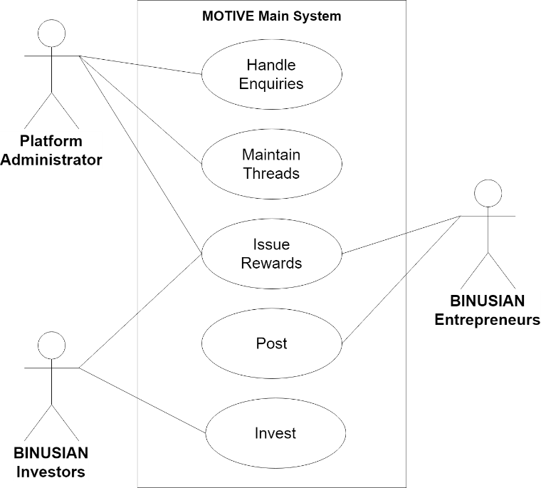

1. **ACTIVITY DIAGRAM**

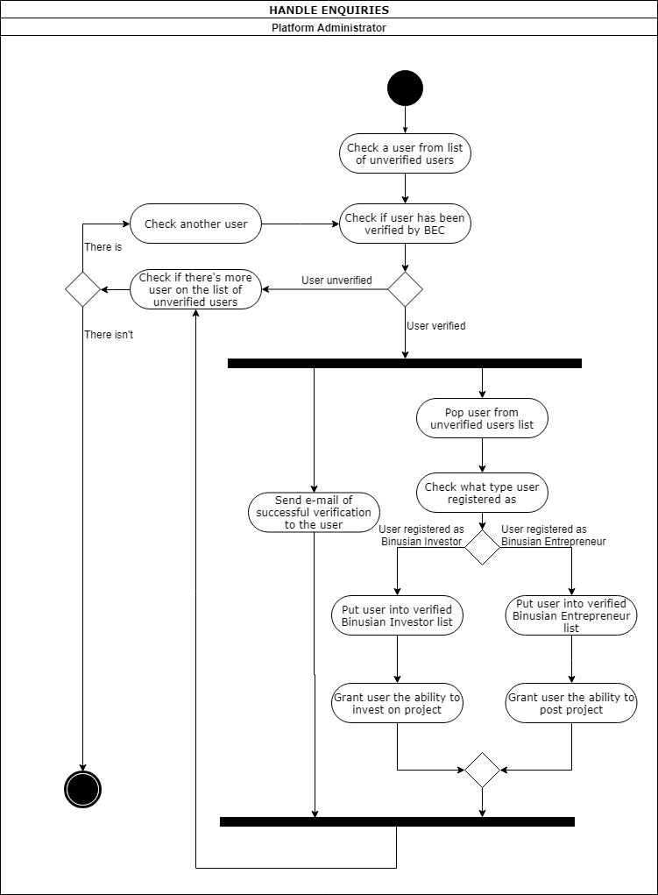

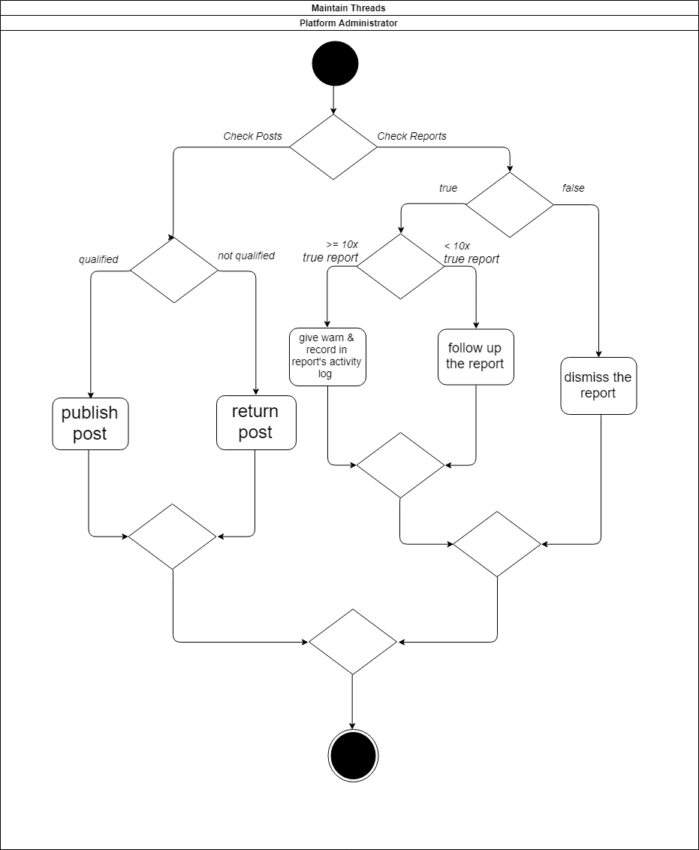

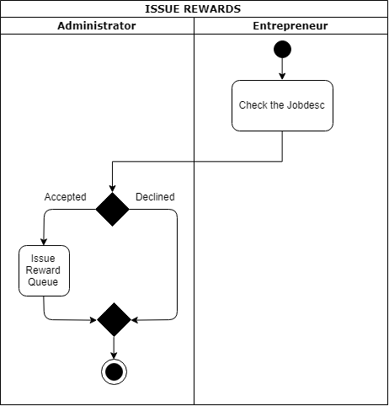

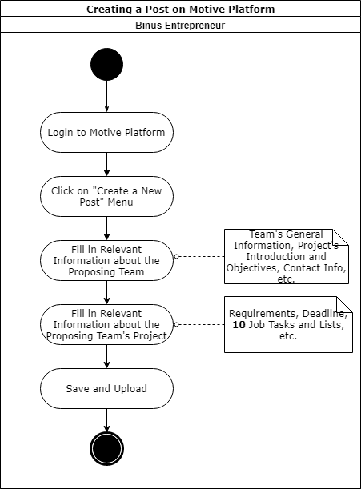

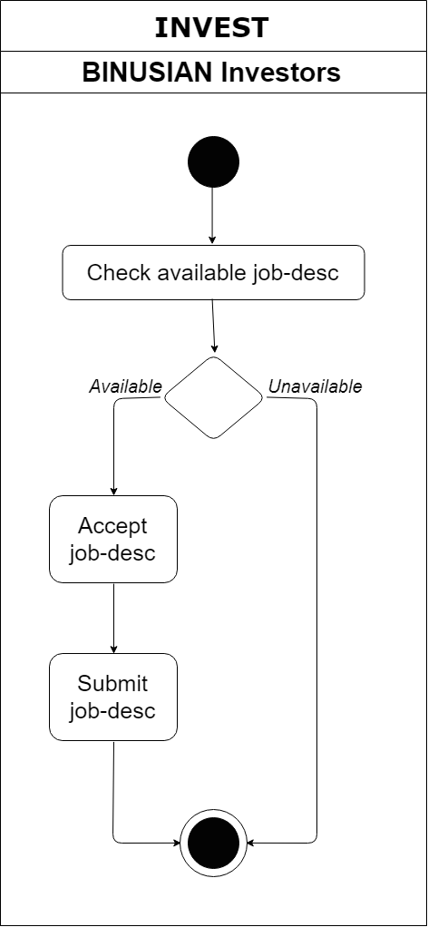

1. **CLASS DIAGRAM**

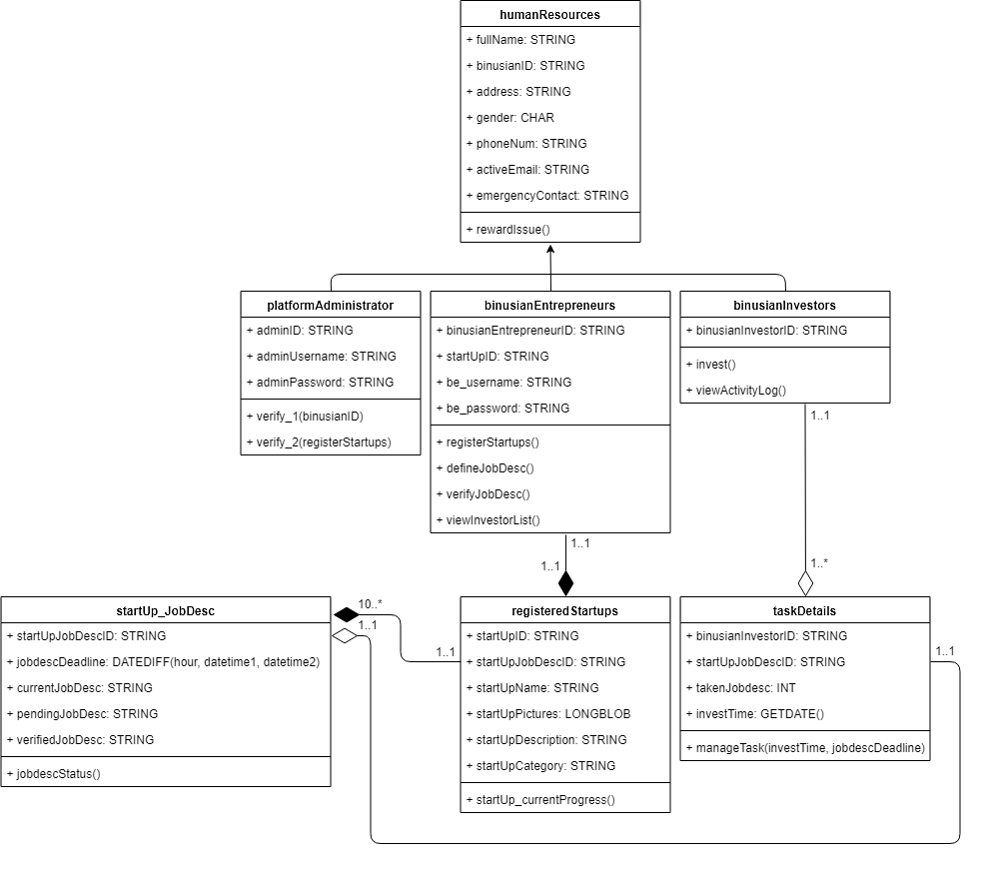

**REFERENCES**

Sameen. (October 04th, 2018). “25 Accidental Inventions That Changed The World”. Retrieved from https://list25.com/25-accidental-inventions-that-changed-the-world/ on March 05th, 2019 02.15 p. m. WIB.

Leo, Rhesa. (November 16th, 2016). “Inilah Karya Anak Bangsa yang Diakui Dunia Tapi Ditolak di Negeri Sendiri”. Retrieved from https://www.yukepo.com/hiburan/life/ inilah-karya-anak-bangsa-yang-diakui-dunia-tapi-ditolak-di-negeri-sendiri/ on March 05th, 2019 02.21 p. m. WIB.

1. Sameen, *25 Accidental Inventions That Changed the World.*
2. Rhesa Leo, *Inilah Karya Anak Bangsa yang Diakui Dunia Tapi Ditolak di Negeri Sendiri.*